Coronavirus disease 2019 also referred to as COVID 19 which is a communicable disease mainly caused by severe acute respiratory syndrome coronavirus 2 (SARS CoV-2). The first case was found in Wuhan, China later it spread across the globe in many countries. It made a huge impact on the lives of people all around the globe. It has been resulted as a pandemic after a wide spread. Some of the common symptoms of COVID 19 are headache, loss of smell and taste, cough, cold, muscle pain, sore throat, etc. As per the statistics, people with the symptoms, 81% develop only mild to moderate level symptoms, while the rest faced high level severe symptoms. It was on 30th January when the first case of COVID 19 has been reported in state of Kerala, India. As per current data, India is listed as 2nd position in world statistics. This has resulted in many adverse effects such as loss of life, unemployment, loss of wealth, etc. Today we witness that many pharmaceutical companies are striving hard for introducing vaccine for prevention of COVID.

**Daily Confirmed Cases per day**

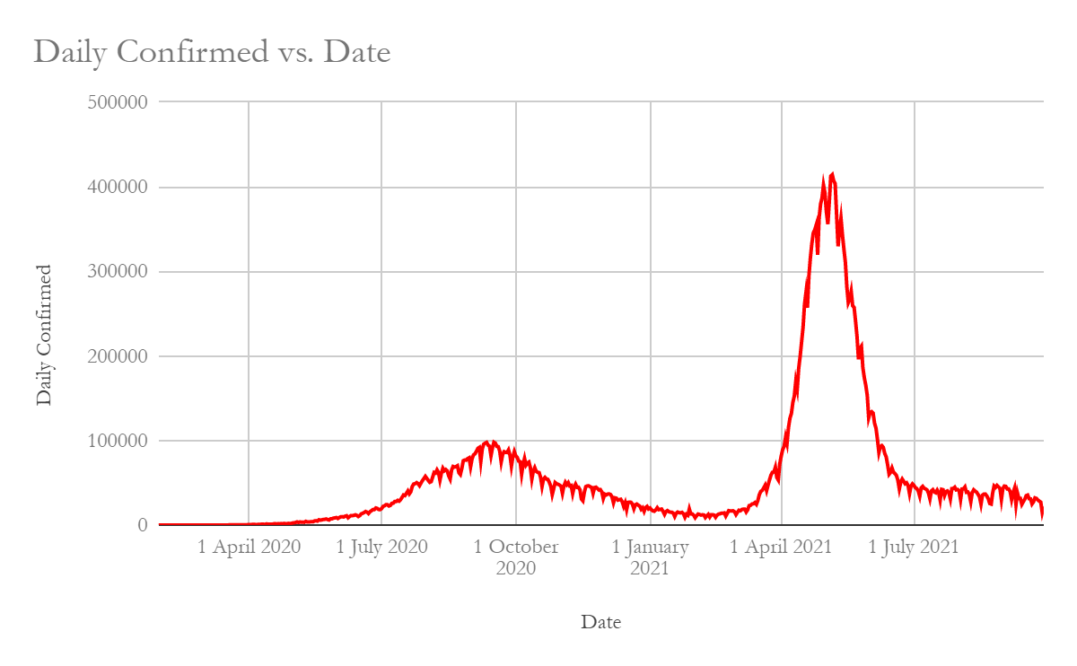

As there are two peaks in the graph, we can assume that there are local maxima and global maxima in the above graph. Here, we observe data from April 1st to present date. During initial days, the cases were few but there is a rapid increase in number of cases, even though there is a downfall of cases over a period but the death rate is comparatively growing at higher rates. In the period of September 2020 – October 2020, the number of cases reached about 1,00,000 per day in India. But after taking certain measures like imposing lockdown in many areas of the country, the government could eventually break the chain of virus that causes a great damage to our lives.

Later, gradually the number of cases has been reduced to about 24,000 cases per day. But due to negligence of maintaining some essential guidelines to prevent the attack of virus, many people have been attacked by COVID 2ave. In this specific duration, the number of cases has reached upto 40,00,000 per day. On 16th September 2020 maximum of 1st wave is recorded i.e., 97860 cases per day whereas in the 2ave maximum cases recorded per day is 414280 on 6th may 2021.

In the following graph we observe total cases confirmed per day,

**Total Cases Confirmed per Day**

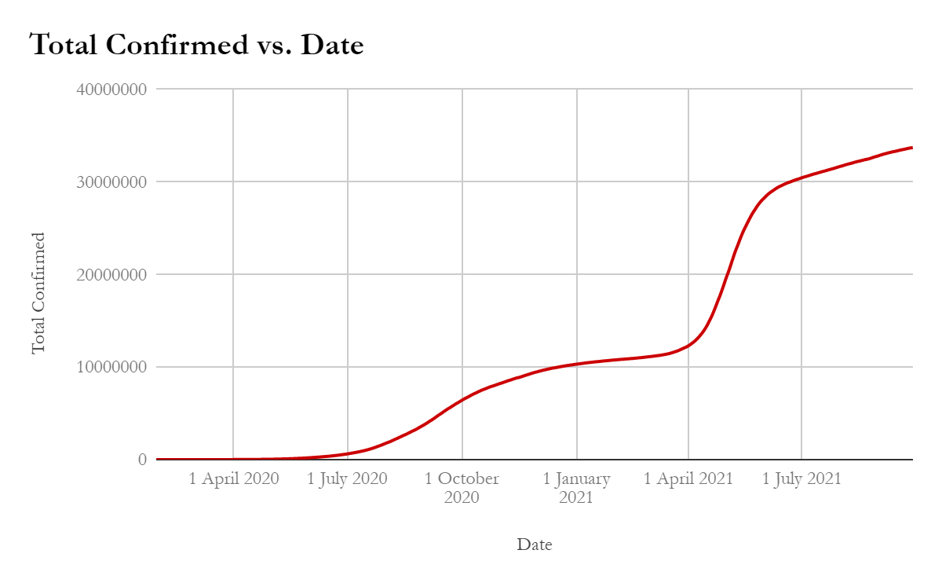

Todate,28-09-2021 cases recorded are 33714828. Total cases recorded in 1st wave are 10916402 and cases recorded in 2nd wave are 22798426.

Now, let us observe the scenario where the recovery of cases per day is visualised-

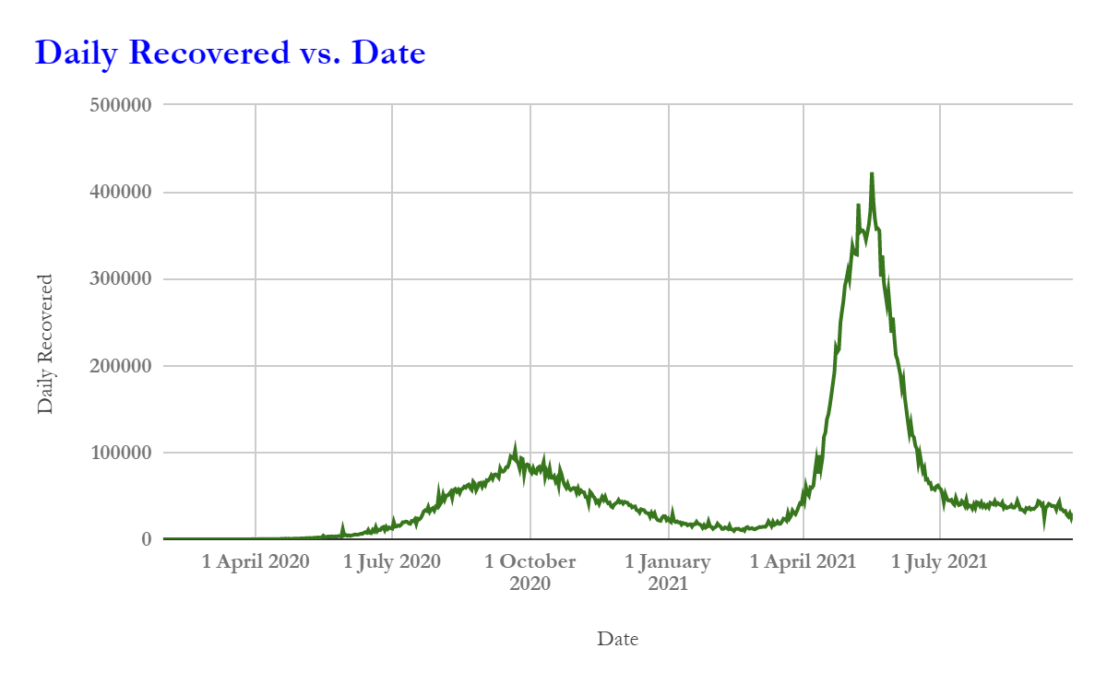

As per statistics, in the pre-mentioned graph, we visualize that number of recovered cases in 1st wave per day is a maximum of about 102070 and in the case of 2 waves maximum cases of recovery are about 422391. We can even observe that as there are 2 maximums and local minimums which further determine that there are 2 waves resulted in this pandemic. As the government started taking many preventive steps to break the chain of the virus by imposing fines for not wearing masks, lockdowns and rigorously working hard to bring vaccines for fighting against the virus, we could observe rapid growth in recovery rate. On average Daily, Recovered cases are 4419704.658, 104250.3709 in the 1st and 2nd wave respectively. The central tendency of whole timeline is 34567.5

Now, let us have a look on total cases of recovery against the timeline-

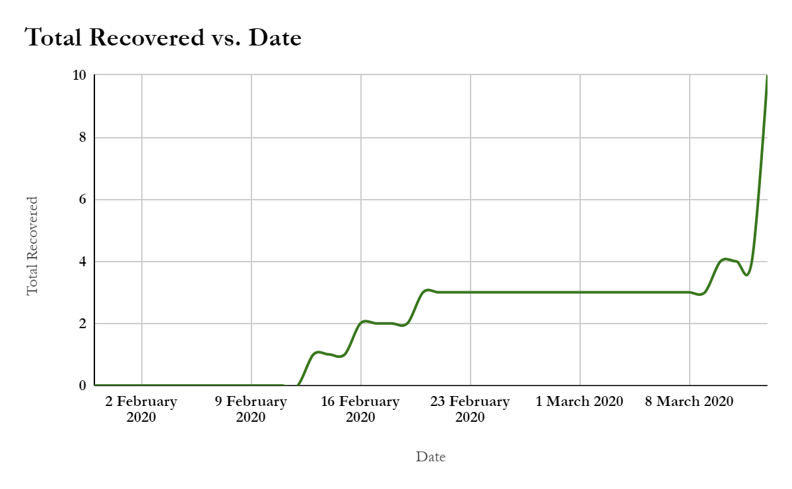Some of statistical measures reveal that around 32978439 have been recovered.

Recovery rate = (Total recovery rate)/(Total confirmed Cases )

= 32978439/33714828= 97.8

That means recovery rate is 97.8 percentage

Now, we will see the daily deceased again the timeline-

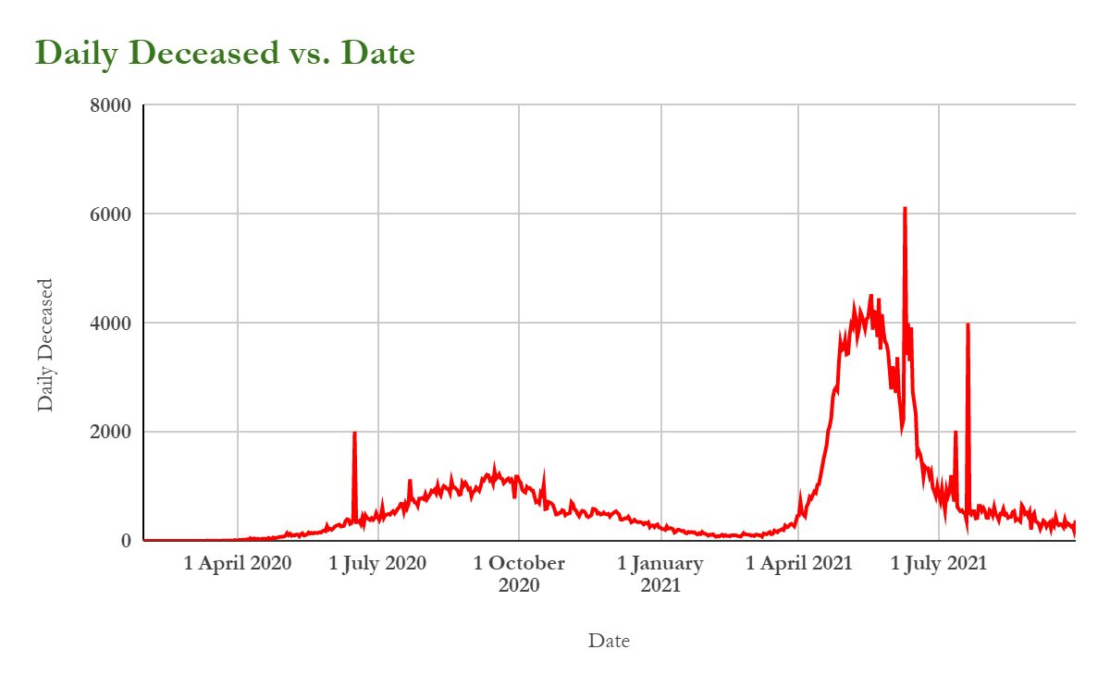

In 1st wave and 2nd waves the maximum death recorded are 2004 and 6139 respectively on dates of 20 uly 2020 and 9 June 2021 but in mid-April the averages deaths recorded are 2000 per day.

.